

CSC 1300 LAB 5 GOLD

**Spring 2023, February 20, 2023 through February 24, 2023**

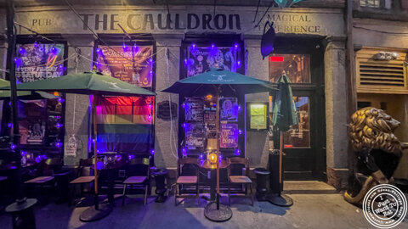

# Concepts

* Menu based program
* While Loops, Do-While Loops, For Loops
* Running total
* Output files

# Description

A new Halloween-themed restaurant has opened in the neighborhood called ***The Cauldron***. Write a program that will take an order from a table and calculate the total for their opening night. The program should also print totals to an output file called **restaurant.txt**.

# Directions

* In your **CSC1300LAB** folder, create a **Lab5gold_yourTTUusername** folder and then create lab5.cpp source file in that folder.
* Create a program that will produce the sample output.
* All money amounts should be printed with two digits after the decimal
* There are only three dishes and their prices should be set as constants in your program. For pizza, there is also a per-topping price, which should also be a constant in your program.
  + Pizza = $20.00
  + Pizza Topping = $2.00 per topping
  + Burger = $15.00
  + Sandwich = $10.00
* There is a grand opening discount as follows:
  + Pizza – 20% off first pizza only
  + Burger – 15% off first burger only
  + Sandwich – 10% off first sandwich only
* You must use at least one **while loop**, **do-while loop**, and **for loop** in this program.
* Output to text file:
  + Notice the money amounts printed to the text file also have two digits after the decimal point.
  + Every line that prints out **“[quantity] [food type] were added and the total is now [total]”** should print to both the screen AND the output text file, **restaurant.txt**. View sample output to find these lines.
  + The line at the end that prints **“The total for your order is [total]”** should also print to both the screen AND to the output text file, **restaurant.txt**.
* Do not use functions (other than main), arrays, pointers, structures, or create your own classes. Do not use any libraries from C++ that hasn’t been discussed in class.
* Validate all input. You may assume the user will enter an integer for menu choice, number of pizzas, and toppings. You may not assume the user will enter in a valid menu option.
* Save your program as **lab5.cpp**.

# sample output

User input is highlighted in **yellow**.

**Welcome to The Cauldron Restaurant!**

**Please choose one of the following options:**

**1 - PIZZA**

**2 - BURGER**

**3 - SANDWICH**

**4 - Done Ordering**

**CHOICE: 5**

**Oops! That is not a valid choice. Choose 1-4.**

**CHOICE: 1**

**How many pizzas do you want to order? 3**

**For pizza 1, how many toppings? 4**

**This pizza costs $22.40**

**For pizza 2, how many toppings? 2**

**This pizza costs $24.00**

**For pizza 3, how many toppings? 5**

**This pizza costs $30.00**

**3 pizzas were added and the total is now $76.40**

**Welcome to The Cauldron Restaurant!**

**Please choose one of the following options:**

**1 - PIZZA**

**2 - BURGER**

**3 - SANDWICH**

**4 - Done Ordering**

**CHOICE: 2**

**How many burgers do you want to order? 1**

**1 burgers were added and the total is now $89.15**

**Welcome to The Cauldron Restaurant!**

**Please choose one of the following options:**

**1 - PIZZA**

**2 - BURGER**

**3 - SANDWICH**

**4 - Done Ordering**

**CHOICE: 3**

**How many sandwiches do you want to order? 3**

**3 sandwiches were added and the total is now $118.15**

**Welcome to The Cauldron Restaurant!**

**Please choose one of the following options:**

**1 - PIZZA**

**2 - BURGER**

**3 - SANDWICH**

**4 - Done Ordering**

**CHOICE: 1**

**How many pizzas do you want to order? 2**

**For pizza 1, how many toppings? 2**

**This pizza costs $24.00**

**For pizza 2, how many toppings? 1**

**This pizza costs $22.00**

**2 pizzas were added and the total is now $164.15**

**Welcome to The Cauldron Restaurant!**

**Please choose one of the following options:**

**1 - PIZZA**

**2 - BURGER**

**3 - SANDWICH**

**4 - Done Ordering**

**CHOICE: 2**

**How many burgers do you want to order? 2**

**2 burgers were added and the total is now $194.15**

**Welcome to The Cauldron Restaurant!**

**Please choose one of the following options:**

**1 - PIZZA**

**2 - BURGER**

**3 - SANDWICH**

**4 - Done Ordering**

**CHOICE: 4**

**The total for your order is $194.15**

(see next page for example restaurant.txt file)

## REsulting Text File after sample output

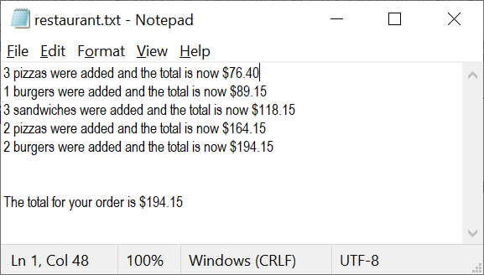

## What to Turn In

**Compress/zip** the **Lab5Gold_yourTTUusername** folder and upload it to the ilearn assignment folder named **Lab 5**.

**NOTE: You do not have to include restaurant.txt or your executable file because we will compile and test your code, which will create these files automatically.**